Census Income Prediction: Data Understanding & ML Flow
Summary
Predicting Annual Income Classification Using Census Data
Develop a machine learning classification model to predict whether an individual's annual income exceeds $50,000 based on demographic and employment-related attributes extracted from the 1994 U.S. Census database (also known as the Adult Income dataset). This is a binary classification problem where the target variable has two classes: “>50K” and “<=50K.”
Understanding the Data and Variables
Dataset Summary
- Source: 1994 U.S. Census Database (extracted by Barry Becker)
- Total Instances: 48,842 records
- Features: 14 attributes (6 continuous, 8 categorical)
- Target Variable: Income (Binary classification: ≤$50K or >$50K)
- Dataset Type: Multivariate, Classification Task

Data Extraction Criteria
The dataset was extracted using the following conditions:
- Age > 16 years
- Adjusted Gross Income (AGI) > $100
- Final weight (AFNLWGT) > 1
- Hours per week > 0

Target Variable
- income: >50K or <=50K

Variable Name | Type | Demographic | Description | Missing Values
age | continuous | Age | N/A | no
workclass | Categorical | Income | Private, Self-emp-not-inc, Self-emp-inc, Federal-gov, Local-gov, State-gov, Without-pay, Never-worked. | yes
fnlwgt | continuous |  |  | no
education | Categorical | Education Level | Bachelors, Some-college, 11th, HS-grad, Prof-school, Assoc-acdm, Assoc-voc, 9th, 7th-8th, 12th, Masters, 1st-4th, 10th, Doctorate, 5th-6th, Preschool. | no
education-num | continuous | Education Level |  | no
marital-status | Categorical | Other | Married-civ-spouse, Divorced, Never-married, Separated, Widowed, Married-spouse-absent, Married-AF-spouse. | no
occupation | Categorical | Other | Tech-support, Craft-repair, Other-service, Sales, Exec-managerial, Prof-specialty, Handlers-cleaners, Machine-op-inspct, Adm-clerical, Farming-fishing, Transport-moving, Priv-house-serv, Protective-serv, Armed-Forces. | yes
relationship | Categorical | Other | Wife, Own-child, Husband, Not-in-family, Other-relative, Unmarried. | no
race | Categorical | Race | White, Asian-Pac-Islander, Amer-Indian-Eskimo, Other, Black. | no
sex | Categorical | Sex | Female, Male. | no
capital-gain | continuous |  |  | no
capital-loss | continuous |  |  | no
hours-per-week | continuous |  |  | no
native-country | Categorical | Other | Country names eg. United-States, Mexico | yes
income | Binary | Income | >50K, <=50K. | no

3. Machine Learning Flow (High-Level Pipeline)

https://www.canva.com/design/DAG_R908W8s/WYfhVuQTN-R3pse-vlreXA/edit?ui=eyJBIjp7fX0
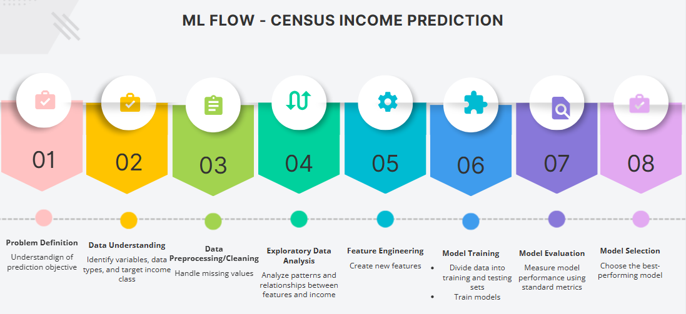

Problem Definition
The objective of this project is to build a machine learning classification model that predicts whether an individual’s annual income exceeds $50,000 based on demographic and employment-related attributes from census data
Data Understanding The census income dataset is analyzed to understand all input variables and the target variable. The data types (categorical and numerical), variable definitions, and the target income classes (≤$50K and >$50K) are identified. Initial observations about data distribution and potential relationships with income are made.
Data Preprocessing/Cleaning The dataset is prepared for analysis by handling missing values in categorical attributes such as workclass, occupation, and native-country. Data consistency is ensured by verifying correct data types and removing any invalid or duplicate records if present.
Exploratory Data Analysis Exploratory analysis is performed to study the distribution of features and their relationship with income levels. Visualizations and summary statistics are used to identify patterns, trends, class imbalance, and potential influential factors affecting income classification.
Feature Engineering Relevant features are selected and prepared for modeling. Redundant or highly correlated attributes are identified to reduce complexity, ensuring that the dataset is suitable for effective learning by machine learning models.
Model Training Suitable machine learning classification models are trained using the prepared dataset. The objective of this step is to allow the models to learn patterns that distinguish individuals earning more than $50,000 from those earning less.
Model Evaluation The trained models are evaluated using standard classification performance measures to assess how well they predict income classes. Model behavior is analyzed to ensure reliable and consistent predictions.
Model Selection Based on evaluation results, the most appropriate model is selected for the income prediction task. This model demonstrates balanced performance and is considered suitable for further analysis or future implementation.

